Maintenance and Help Guide

How to install the system:

1. Download the zip folder that contains the files necessary to run this site.

* 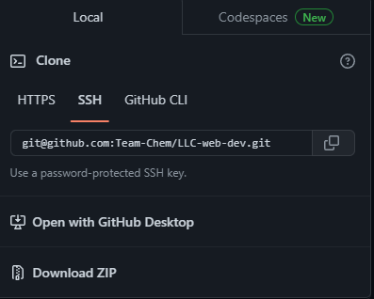
* There will be two folders within this zip file "app" and "db".

1. Software used to run localhost and phpMyAdmin:

* XAMPP - <https://www.apachefriends.org/download.html>
* This software has built in Apache and phpMyAdmin to run the localhost on your machine and allows the user to easily create and maintain a database.

1. How to use setup and use XAMPP:

* Go to the link in step 2 to download and install the XAMPP software for your corresponding machine.
* Once the software is installed, follow the file path and go into the “htdocs” folder.
* 
* This “htdocs” folder is where all the files for the code will have to be stored inside of. This allow the code to be rendered through Apache on the XAMPP software.
* If you want to have an organized file directory, you can create additional folders inside the “htdocs” folder and store the folders that contain the code.
* Graphical user interface

  Description automatically generated
* In the image above, there were 2 folders created in the “htdocs” folder. A folder for this current project and another folder inside the “project” folder that contains the code for this project.
* After this is done, you can boot up the XAMPP software.
* If you’re running the XAMPP software on Windows, set it to where when you launch the software it is launched through administrative mode. This will limit or eliminate all the problems that you will have with this software.
* When the software is launched, it should look like this.

* Press “start” for Apache and MySQL and click on “Admin” to open a new window.
* You will be redirected to a local dashboard page for XAMPP. This is how you know you know that Apache localhost is working.
* At the top of the page, you will see a “phpMyAdmin” button. When you click this, you will be redirected to the phpMyAdmin database page.
* Text

  Description automatically generated
* You can also access this page by clicking on the “Admin” button on the XAMPP Control Panel.
* Going back to the localhost dashboard page, a way to access the folders that contain the code is to go to the URL bar where is show “localhost/dashboard” and go to the correct file path.
* 
* Graphical user interface, text, email

  Description automatically generated
* localhost>project>capstone>app>views>pages.
* This file path will bring you into the pages folder where the pages will be rendered